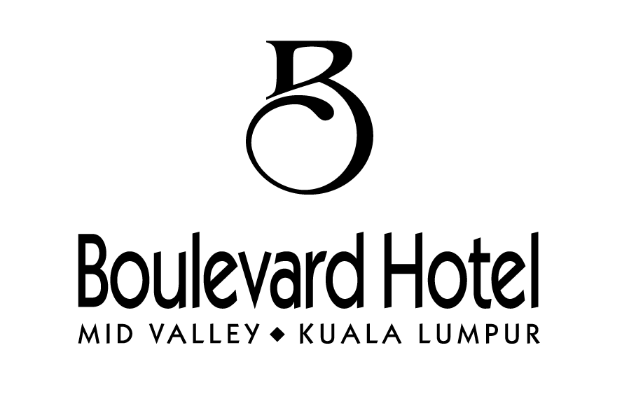
RESERVATION FORM
WORLD ALLIANCE FOR PENTECOSTAL THEOLOGICAL EDUCATION
26-27 AUGUST 2013
(Note: can be extended for dates before and after the conference)

For room reservations, please e-mail or fax to below not later than 06 August 2013. Only completed forms will be accepted and confirmed.
Boulevard Hotel
Email: resvnkul@blvhotel.com / resvnkul2@blvhotel.com / adoskul@blvhotel.com / suyee.mktgkul@blvhotel.com
Phone: + 60 3 2295 8111 Fax: + 60 3 2287 8775

 | NEW |  |  | AMENDMENT |  |  |  | CANCELLATION

Mr/Mrs/Ms ____________________________________________________________________
Company ____________________________________________________________________
Business address ____________________________________________________________________
City ___________________ State _____________________ Postal Code ____________
Country ____________________________________________________________________
Tel ___________________ Fax ____________ Email ___________________________
Arrival _____/______/_______ Flight _____________________ Time _________________
Departure _____/______/_______ Flight _____________________ Time _________________
No. of Room(s) ___________________ No. of Guest(s) ____________________________________

ROOM TYPE | ROOM RATES
ROOM TYPE | Single / Twin
Superior | ( ) RM 298.00nett
Executive Superior | ( ) RM 353.00nett
Special Request  (Subject to availability) | ( ) King Bed ( ) Twin Bed  ( ) Smoking Floor ( ) Non Smoking Floor
- The above rates are on a per room per night basis, inclusive of 10% service charge and 6% government tax.
- The above room rates are inclusive of buffet breakfast at Wild Rice Restaurant and internet usage for 01 or 02 users.
- Extra bed with 01 breakfast will be charged at RM 80nett per night for Deluxe Room category and RM 100nett per night for Executive Rooms.
- Standard check-in time at 2.00pm and check-out time at 12.00nn.
- Extra amenities for Executive Room at Executive Lounge.
- Cancellation: All reported bookings received by and after cut-off will be treated as guaranteed reservations and will be subjected to cancellation charges.
- 07 working days prior to arrival date – One (1) night’s charge.
- No Show – Full length of stay
PAYMENT |  | CASH |  |  | CREDIT CARD
Card Type Amex / Visa / Master / Diners / JCB
Card No _____________________________________
Name on credit card _____________________________________
Expiry Date _____/___ _/______ CVV no / Security code: ___________________________
Signature / Date __________________________________________________________________

FOR OFFICE USE ONLY

Reserved By __________________________________ Date: _______________________
Confirmation # __________________________________
Remarks __________________________________________________________________

Mid Valley City, Lingkaran Syed Putra, 59200 Kuala Lumpur, Malaysia
Tel: 603 2295 8000. Fax: 603 2287 8775. Email: infokul@blvhotel.com.Website:www.blvhotel.com
(Mid Valley City Enterprise Sdn Bhd – Company No: 6968-K)

